1. Download XAMPP from <https://www.apachefriends.org/index.html> :.

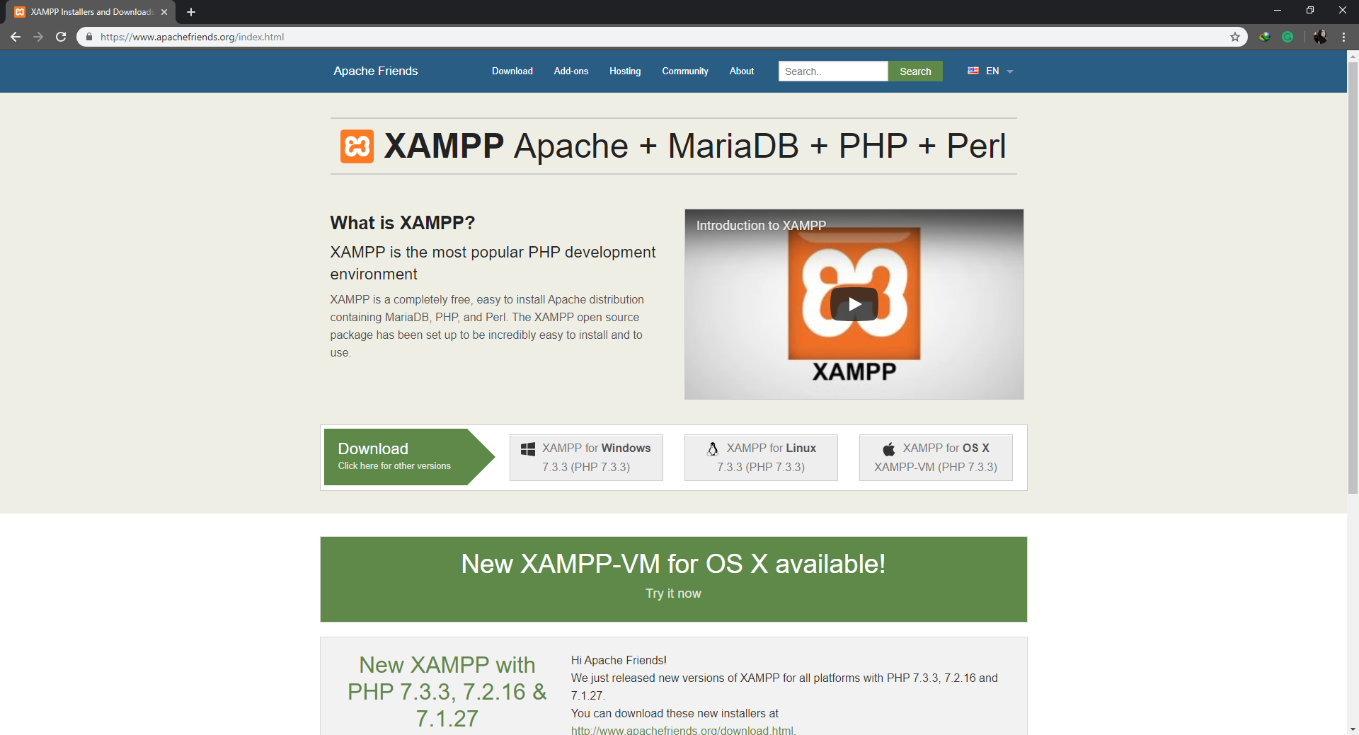

1. Run XAMPP Control Panel, then click the start button beside Apache and MySQL:

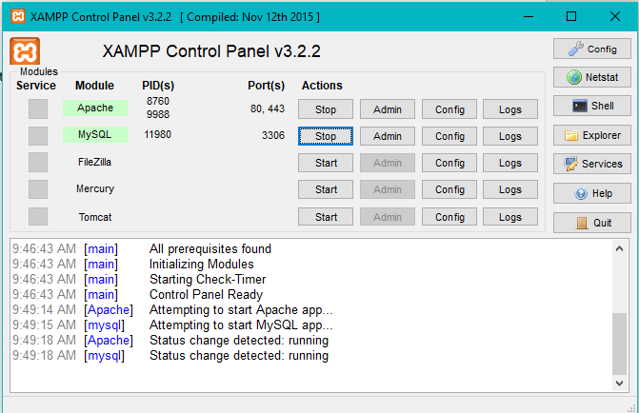

1. Move the system folder to “ xampp/htdocs/”:



1. Type <http://localhost/ReFeel/views/doctor-login.php> on the browser to go to the admin log in page:

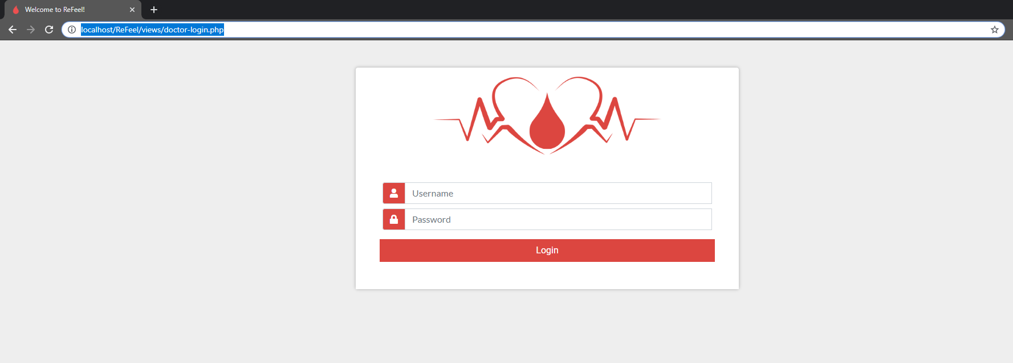

1. Type <http://localhost/ReFeel/bbmis-donor/home.php> on the browser to go to the donor log in page:

